Searching for My Heritage

Telling My Story

In April 2005, I listened to a keynote speech at the annual Order of the Crown of Charlemagne meeting that explored the process and the emotions associated with this individual’s search for his ancestors. I realized that each of the avid genealogists in attendance that night had their own story to tell of how they began their own search for their heritage and the things that they learned and experienced along the way. Since my own search has had some interesting twists and turns, I decided to chronicle it so that I could share it with others.

Looking Over My Mother’s Shoulder

I hadn’t thought much about my own heritage until my mother started looking for her biological parents in the early 1970s. Her adoptive parents had been “Nannie” and “Gramp” to me for more than twenty years, and along with my dad’s mother, “Grammie,” they were all the grandparents that I needed. When my mother started working backwards from her adoption certificate things started getting exciting. Although there were a few dead ends, research led to several of the earliest families of New England. My mother eventually registered lines with the Mayflower Society that tied us to six signers of the Mayflower Compact: William Brewster, Peter Brown, Steven Hopkins, John Howland, Thomas Rogers, and John Tilly. In total we have ten different lines registered to these six Mayflower Compact signers as a result of the different New Plymouth Colony children through whom we are descended.

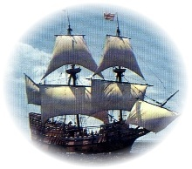
I already knew that the courageous group of 102 passengers who arrived on the Mayflower were known as the “Pilgrims”. I also knew that they arrived at New Plymouth Colony or sometimes “Pilgrim” Colony, now known as Plymouth, Massachusetts, in 1620 and established the second oldest permanent English settlement on the American East coast. However, I did not know that half of them did not survive the hardships of their first winter. I also learned that the Mayflower Compact is considered to be the first written declaration of self-government and therefore a precursor of the Constitution of the United States. I had visited the town of Plymouth as a small boy, later as a teenager, and again as an adult with my own children. I had marveled at the small size of the famed “Plymouth Rock” and the primitive conditions of the recreated settlement named Plymouth Plantation. However, until my interest in my heritage sparked further study, I did not fully appreciate that the perseverance of the colonists at Plymouth lead the way to establishing religious freedoms and creating the foundations of democracy that Americans enjoy today. It certainly made it more understandable why their celebration of the first Thanksgiving has grown to become a festive national holiday.

Increased Interest Resulting from Exciting Finds
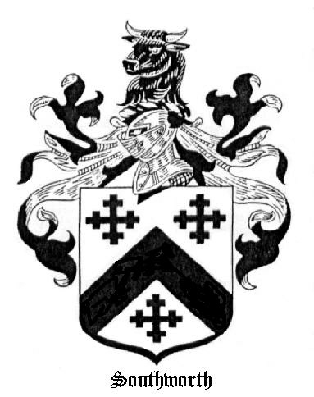
Although all of the Pilgrims were of English descent, many had spent the ten years prior to their voyage in Leiden, Holland, where they had been able to worship as they wished under lenient Dutch law. Their reason for leaving Holland was based on a fear that their children were losing their English heritage and religious beliefs. In August 1620 a group from Leiden sailed to Southampton where they finally headed to the New World aboard the Mayflower along with an equal number of like-minded Englishmen. I was surprised to learn that a sister ship was also outfitted for the voyage, but unable to make the trip since it proved to be unseaworthy. After the success of this initial group, additional Leiden parishioners made their way to the Cape-Cod area of what was then known as northern Virginia. One of my immigrant ancestors that followed the pilgrims to the New World was Constant Southworth. He came to Plymouth sometime after 1627, most likely living with his mother, Alice, and her husband, Gov. William Bradford.
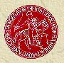
I was fascinated to learn that Constant was a proven descendant of Magna Charta Sureties and Charlemagne. It was at this point that I got really interested in my heritage. I learned that the Magna Charta is such an important symbol of freedom that it is referenced in the Rotunda of the National Archives as a key precursor to our own Declaration of Independence, the United States Constitution, and the Bill of Rights. These three documents are all proudly on display and are referred to as the Charters of Freedom. In fact, a 1297 version of the Magna Carta is also on display and shares space in the National Archives Rotunda. As a precursor to the Charters of Freedom, the Magna Charta document drafted in 1215 gave protection to the rights of the nobles and common citizens alike to be free of arbitrary actions against their persons or property by their sovereign. It has come to be recognized as the first cornerstone of liberty and justice in the western world. The fact that my ancestors played a part in the negotiations with King John of England and the eventual ratification of this amazing document sparked both my interest in history and my own involvement in the search for my heritage.

Wondering Where the LaRochelle Name Originated

Since my mother was doing all the work identifying my heritage through her ancestors and I was only involved in as an avid spectator, I started wondering about where my LaRochelle surname originated and whether my father shared as fascinating a heritage as my mother did. My first step was to discuss my interest with Grammie. My dad’s mother informed me of what little she knew about the Fournier family from which she descended. More importantly, she alerted one of my third cousins from the LaRochelle side of the family of my interest. This cousin had started a search of her own and had identified ten generations of the principle male line dating back to Michel Gautron dit LaRochelle. Michel was the son of Daniel Gautron and immigrated to New France on the 25th of May in 1664. Michel hailed from the seaport city of LaRochelle, France, and thereby inherited the nickname, or more formally known as a sobriquet, “dit LaRochelle” during his early days in Quebec. I learned that it was common practice for the early French settlers to assign sobriquets to each other. These nicknames might identify where they were from as it did in Michel’s case, a physical attribute such a “tall”, “short”, “thin”, or “fat”, or be a play on words such as “Laforest dit Labranch”. From my research, the sobriquet simply seems to be a spontaneous refinement of someone’s name that was derived according to the whim of that someone’s friends and neighbors.

Researching Ten Generations of Spouses

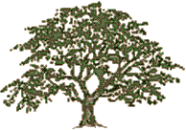
Now that I had a starting point, I was determined to start performing my own research. However, I had no idea how to get started. I mentioned my dilemma to a next-door neighbor and he recommended that I go to the nearby Mormon Church to start my research. I thought that he must be pulling my leg, but he assured me that he was quite serious and that I could get help at the Mormon Church. It was around 1977 when this occurred and it took me a full year before I got the nerve to do what he suggested. I finally headed up to the church and after walking around; I found a door labeled “Family History”. Inside this door I found several metal cabinets and a number microfiche and microfilm viewers on folding tables. I started rummaging through the microfiche and quickly learned that I had no clue what I was doing. My desperation must have shown since I was soon asked by a volunteer librarian whether I needed some assistance. Somewhat embarrassed and very ill at ease, I explained what I was hoping to do. As luck would have it, this rather elderly lady’s husband was also French Canadian and she had been busy researching his ancestry. Many of the materials that she used in her research were on indefinite loan from the Mormon Resource Library in Salt Lake City.

These materials turned out to be a gold mine for my research efforts. I very quickly identified the parents, grandparents, and great grandparents of virtually all the spouses of my earliest immigrant ancestors. As I identified the immigrant ancestors of each of these new family lines I would back up a generation and start over again. I did not realize at the time that it is quite unusual to start a heritage search ten generations upstream and then work backwards, but it certainly paid off for me. Within four months I had identified several hundred ancestors and was finding more in almost every trip to the library. It was at this point that two significant events happened.

The first event occurred at the church’s Family History Library. My helpful volunteer librarian introduced me to an octogenarian church member who had been researching her own family for forty years. The librarian asked me to show off my stack of family group sheets and family tree charts. The spindly church member was very impressed with my results and asked how long I had been at it. When I replied that it had been four months, she physically struck me on the arm and walked off. The librarian was speechless and I was totally shocked. It was at this point that I started to understand how emotional the search for one’s heritage could become. It took me some time to appreciate what had happened, but I eventually came to understand that my new acquaintance was jealous to the point of being offended by the rapid progress of my research. I had accomplished in four months what her experience suggested should have taken several years or more.

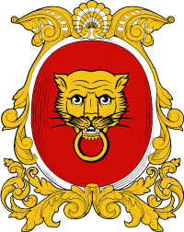
The second significant event occurred at home. My wife informed me that she was unhappy being a “genealogy widow.” She advised me that I was welcome to spend one night a week or Saturday at the Family History room, but I had to discontinue my current practice to pursuing my research two or more nights a week and on Saturday. The lesson that I learned from this event is that everyone does not associate the same worth and value to genealogical success. Fortunately, the reduced effort did not restrict my continued progress. My efforts eventually uncovered Catherine de Baillon and my second line to Charlemagne through a number of French nobility.

de Baillon Armorial

The History of New France

I learned that Catherine de Baillon was a “filles du roi” or King’s Daughter. She and approximately 770 other women arrived in New France between 1663 and 1673 under the financial sponsorship of King Louis XIV of France. Most were single women and many were orphans. Their transportation to Canada and settlement in the colony were paid for by the King. The King even provided many of the filles du roi with a dowry of 50 livres for their marriage to one of the many unmarried male colonists in Canada. These gifts are reflected in some of the marriage contracts entered into by the filles du roi at the time of their first marriages. The filles du roi were part of King Louis XIV’s program to promote the settlement of his colony in Canada. Some 737 of the filles du roi married. These marriages resulted in a population explosion that contributed to the success of the colony. Through my research, it became apparent that the vast majority of the millions of people of French-Canadian descent throughout North America are descendants of one or more of these courageous women of the 17th century.

During the same period that the filles du roi were being recruited for New France, the French-Canadian farmers were being terrorized by the Iroquois Indians. Pleas for assistance in their struggle with the “Iroquois Menace” were answered in 1665 with the arrival of the first regular fighting forces in Canada. Some 1,200 soldiers and their officers of the Carignan-Salieres Regiment arrived between June and September 1665. They were under the leadership of Lt. General Alexander de Prouville, Sieur de Tracy. The regiment established a series of forts along the Richelieu River. From these forts they launched campaigns into the land of the Mohawk tribe of the Iroquois Nation. The success of the second campaign was so successful that it led to a long period of peace for the colony and permitted it to prosper. Although they had accomplished the undertaking that brought them there, King Louis XIV’s plan included the permanent settlement of many of the soldiers and officers in Canada. Over 450 of these troops remained in the colony, many of whom married a newly arrived fille du roi. Most persons of French Canadian descent can claim one or more of these brave soldiers as ancestors as well as a one or more of the fille du roi. The Carignan-Salieres Regiment did not act alone in putting down the Iroquois threat. Many militiamen who resided in the colony participated in the successful campaign. However, the names of the militiamen were not recorded for posterity. Efforts to honor the 17th century men who paved the way for growth and prosperity of New France is usually restricted to the named soldiers of the Carignan-Salieres Regiment.

Early in my research, I made an observation that that completely puzzled me. All my French- Canadian lines tied me back to ancestors who immigrated to North America prior to 1744. I was quite aware that immigration to North America did not peak until the early part of the twentieth century. Why did all my French-Canadian ancestors arrive by the early part of the eighteenth century? I eventually learned that although the early colonists of New France were very open to settlers from all over the European continent, this ended when they lost the French and Indian War in the middle of the eighteenth century. Before ending up on the losing side of the war with Great Britain, my ancestors included immigrants from Portugal, Spain, Switzerland, Germany, Scotland, Ireland, Belgium, and England along with the many settlers from France. All of these individuals were welcomed into and assimilated by the French-Canadian culture. However, the welcome mat was locked away once the colony was placed under British rule. The French-Canadian culture became much more inward focused and close-knit. This is a phenomena that is largely true today.

Another phenomena that puzzled me was why so many French Canadian ancestors shortened their names during the mid 1800s. My family name had remained Gautron dit LaRochelle until my great-great-grandfather changed his name from Edouard Alphonse Narcisse Gautron dit LaRochelle to Edouard LaRochelle. The reason for this common practice or shortening names turned out to be a simple one. It was due to the advent of public education. As the citizens of Canada learned to read and write, they decided that a shorter name would be more practical. When a priest was recording a birth, death, or marriage it was fine to make him write out entire names. When a notary was recording a sale of property of some other civil event, it was again fine to have him write out entire names. However, when the citizens themselves had to start signing their own names, they elected to either drop the sobriquets or else adopt the sobriquets as part of a shortened moniker.

Volunteering To Collaborate on Republishing Three Books of Histories

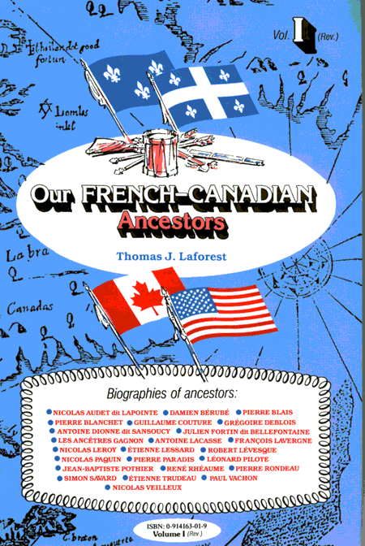
In the course of my research I came across a set of books titled “Our French-Canadian Ancestors.” Each of these volumes was originally written in French and then republished in English and contains a collection of stories about early French-Canadian immigrants. After purchasing the first several volumes of what turned out to be a thirty-four volume set, I decided to contact the coordinator of the English translations, Tom Laforest. I wrote a letter expressing my appreciation for his efforts and volunteering to provide assistance if needed. Mr. Laforest sent me back a reply that advised me that although he had received numerous letters of appreciation, mine was the first to offer to help. Since he was currently working on Volume 10 including a story about my ancestor Michel Gautron dit LaRochelle, my timing was opportune. I proofread the story and forwarded several suggested corrections. I also assembled a story regarding Louis Hebert that was refined by Tom and included in the same volume. After this minor involvement, Tom asked me to assist in the republishing of the first three volumes that were all published before he had switched from type-writer generated copy to personal-computer generated copy. Over the next three years we collaborated to republish each of these volumes. I would re-key as much of the original volume as my schedule would allow and reorganize the listing of offspring by ensuring they appeared in age sequence and included pertinent information regarding their marriages and number of children. It was really exciting to receive my copy of each of these volumes and see my name listed along with Mr. Laforest’s name as a co-contributor for the republishing.

Working on a Reference Book of Name Cross References

Mr. Laforest also got me started on a major publishing effort that I have been working at for over a decade. He suggested that we collaborate on a name cross reference to assist the research efforts of folks with French-Canadian ancestry. For many descendants, the surname has changed through the ages and it is difficult to identify the original surname of their immigrant ancestor. There have been numerous name cross references produced, but all earlier efforts simply indicate that an individual with a given surname might be related to an individual with another surname. The effort that I initiated at Mr. Laforest’s suggestion actually provides the full name along with pertinent marriage information. I have invested hundred’s of hours of effort over the past decade and am in the process of making a final clean-up pass before exploring the options of finally getting this new reference work published. This effort represents my desire to assist future generations with their research efforts.

Learning About Charlemagne

Knowing that I was descended from Charlemagne, I also set out to learn something about him. Eventually my search happened upon The Life and Time of Charlemagne by Einhard. Since Einhard was a member of Charlemagne’s court, the account provides vivid detail and fairly reliable insight into the life of a ruler who remains a legend and icon of history over a millennia after his death. The chronicle was completed about 830 AD and reports on the great Frankish King through his battles as general; his responsibilities as a husband and father; and his devotion to education and the arts. In addition to providing a chronicle of virtually every battle, Einhard shares observations regarding the King’s personal appearance, his dress, and his habits. He delves into Charlemagne’s studies, his piety, his generosity, and the reforms that he effected. I learned that, although he inherited a kingdom of illiterate farmers, he forged it into an empire that was militarily strong and culturally advanced. It has been argued that the main achievements for Charlemagne’s reign were all started by his father. However, he had the strength and foresight to carry through what his father had begun. The alliance with the church, the conquest of the Moslem neighbors, the reform of government machinery, and the improvement of scholarship and education all came together under his tutelage to be regarded by scholars as the most brilliant reign of the Dark Ages. Charlemagne was not regarded as a scholar and did not learn to read until late in life. However, the development within the boarders of his empire of a climate favorable to education and the arts is attributed to be a direct result of his enthusiasm as ruler.

Joining The Order of the Crown of Charlemagne

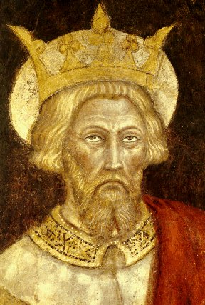
After being thoroughly impressed with my new knowledge of Charlemagne, I enlisted my mother’s assistance in assembling the necessary proofs to apply for membership in the Order of the Crown of Charlemagne. We were fortunate in that we had a close family friend as well as a genealogist acquaintance that were OCC members and able to recommend me for membership. My application was accepted and my proofs verified to the satisfaction of the Genealogist General. I received my certificate of membership signed by then president Timothy Field Beard on 8th of March 1993. My portal ancestor was my first identified Charlemagne connection mentioned earlier as Constant Southworth who had joined New Plymouth Colony shortly after its settlement. Unfortunately, my actual participation in OCC events would be delayed more than a decade by my responsibilities as husband, father, and employee.

Attending the Annual Meetings

I attended my first Order of the Crown of Charlemagne annual meeting in 2004. It proved to be a significant emotional event. I had arrived early to ensure that I could find the University Club from my study of a Washington D.C. street map. This gave me time to chat with other members before heading to the dining room and sitting down with a new group with whom I could continue my conversations. Although I have had the pleasure of visiting the Family History Library in Salt Lake City where I felt a certain comradeship with the other visitors, it was an entirely different feeling at the annual meeting. It was not simply comradeship; it was family! I was among a room full of people who were as passionate as I am in searching for their heritage. The keynote speaker was a history professor who spoke of the Three Empires. He took us on a virtual tour of history by following the Holy Roman Empire, the Byzantine Empire, and the Moslem Empire from their initial formation to modern day. He discussed the impacts that each of these empires has had on civilization and each other. Although he covered over 2,000 years of history, he made it interesting and entertaining.

Supplemental Membership

I was so pleased and impressed with my first annual meeting that I decided to register a supplemental membership through my father’s link to Catherine de Baillon. This time the proof would come from my own research rather than that of my mother. I did not make my goal of completing this task before the 2005 meeting, but on the 23rd of May, 2005, my supplemental membership was approved by Timothy Field Beard as the current Genealogist General and signed by Richard Calendine the current President General.

A Second Annual Meeting

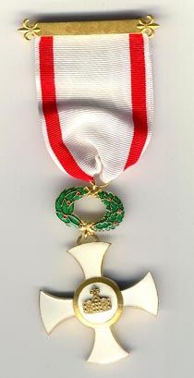
I attended my second Order of the Crown of Charlemagne annual meeting in April, 2005. I experienced much of the same excitement and anticipation as the first meeting. However, this time I knew what to expect. I found new friends to talk to and continued to be fascinated by all the societies that many of the other members belong to. I will always remember how distressed one of my dinner companions was when she asked me: “What other societies do you belong to?” When I responded that Order of the Crown of Charlemagne is my only membership, she exclaimed that “No one starts with the Order of the Crown of Charlemagne. It simply isn’t done. Everyone works their way up to it.” Well, the Order of the Crown of Charlemagne continues at least for now to be my only membership and I am delighted that I started where I did. As this address bears evidence, I am committed to the Order’s Objectives as defined in the website:
- To perpetuate the memory and to honor the name of Emperor Charlemagne;
- To bring into one group the descendants of his successors and heirs;
- To maintain and promote the traditions of chivalry and knighthood;
- To recognize acts of merit;
- To recognize achievements in the Arts, Sciences and Letters;
- To inspire patriotism and loyalty to our country.

For those who were not there to enjoy the 2005 Annual Meeting, it was Timothy Field Beard past President and current Genealogist General of our Order that inspired me through his account of his own search for his heritage. I hope that my own account has provided some of the same inspiration and entertainment that I received from him.

